IBM Watson Studio – Data Preparation and Dashboarding Workshop

Prerequisites: IBM Cloud account, a Cloud Object Storage service instance, and a Watson Studio service instance.

In this tutorial we will create visual dashboards from refined data to gain insights. This tutorial contains two services: a data container service and a Dashboard service.

The sample data is the **Sales and Marketing.csv** file.

You should be able to complete the tutorial in 25 minutes depending on loading and running time.

The following tutorials assume that you have an IBM Cloud account. If you do not have an account you can create one at [cloud.ibm.com](https://cloud.ibm.com/). To get started, go to [dataplatform.cloud.ibm.com](https://dataplatform.cloud.ibm.com/) and sign in with your IBMid.

Part 1: Set up the project

Step 1: Create a Watson Studio Project

1. On the Watson studio start page, click the **Create a project** card.
2. Select the **Create an empty project** card.
3. In the right side of the New Project page click Add to add a cloud object storage instance to your project.
4. Select the **Lite** plan and click **Create**. Click **Confirm** in the popup that appears to proceed.
5. Back in the New Project page click on refresh to associate the cloud object storage instance you created with your project.
6. Name the project “**Sales and Marketing – Analysis**”
7. You can add the description of “*Investigating the Business Analytics project starter”.*
8. Click on **Create**.

To learn more about the hosting services, see https://bit.ly/2Q5YhvS for more details.

Step 2: Add the Data.

1. Click on **Add to project.**
2. Select the **Data** card**.** This will open the data side panel.
3. Drop the Sales and Marketing.csv file or select **browse** to add the Sales and markering.csv file.
4. Move to the **Assets** tab.

Part 2: Refine the data

1. In the assets tab select and open the Sales and Marketing.csv
2. You should see the this

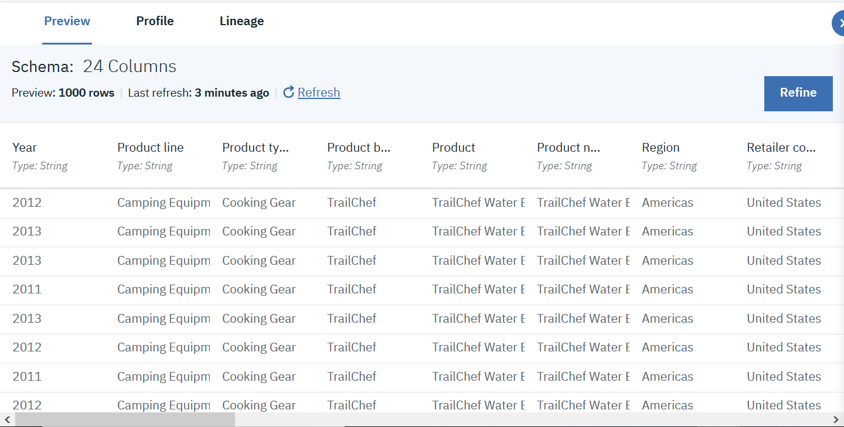

1. Click on the **Refine** button. We will now start by refining the **Revenue** column (you may need to scroll).

Refining data consists of cleansing and shaping it. When you cleanse data, you fix or remove data that is incorrect, incomplete, improperly formatted, or duplicated.

When you shape data, you customize it by filtering, sorting, combining or removing columns, and performing operations.

As you manipulate your data, you build a customized Data Refinery flow that you can modify in real time and save for future re-use. When you save the refined data set, you typically load it to a different location than where you read it from. In this way, your source data remains untouched by the refinement process.

1. Hover over the column till the vertical ellipses appear, then **click** the vertical ellipses.

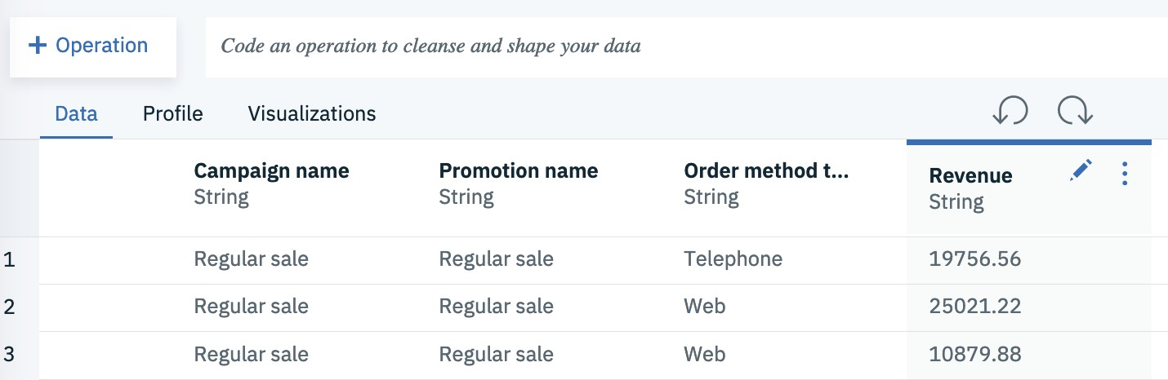

1. On the drop-down menu, click **CONVERT COLUMN**.
2. 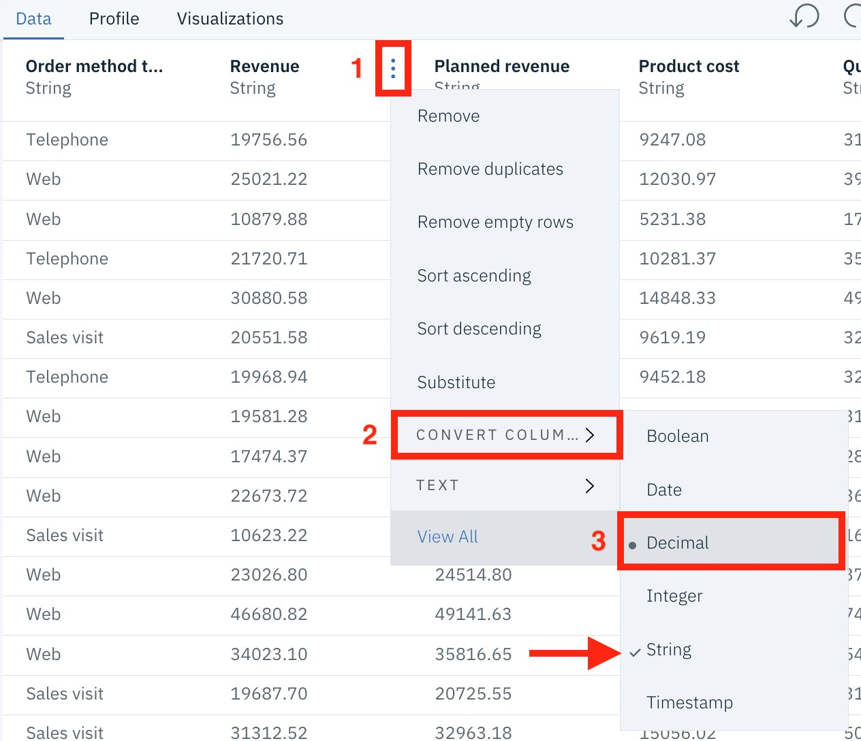Click the **Decimal** option.

Notice that the string option shows a **checkmark** – this indicates the current type of the column. You will also notice that Decimalhas a ***dot*** indicator – this indicates the suggested conversion you should use.

1. Repeat the steps for the following columns:
   * Planned Revenue 🡪 Decimal
   * Product Cost 🡪 Decimal
   * Quantity 🡪Integer
   * Return Quantity 🡪 Integer
   * Unit cost 🡪 Decimal
   * Unit price 🡪 Decimal
   * Unit sale price 🡪 Decimal
   * Gross profit 🡪 Decimal
   * Promotion Plan Revenue 🡪 Decimal
2. Click on the **Operation** button.
3. In the side menu that opens up click on **Calculate**.
4. Select the **Gross profit** column and click **Next** below.
5. Select **Division** as the operation to apply.
6. Choose the **column** option and select the **Revenue** column.
7. Check the box: **Create a new column for results**.
8. Name the new column “**Profit margin**” and click **Apply**.

Profit margin = Gross profit / Revenue

1. After you do this you should have **10 steps** in the **steps panel.**

If you want to reverse any changes, simply hover your cursor over the change, at which point a trash can icon will appear and the change will have a strike-through (delete) appearance to it. Click on the trash can icon to delete the change.

1. Click the 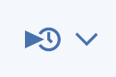 icon and select **Save and create job** to apply the transformations to the data.
2. Name the Job **“Transformations”** and click **Create and Run**.

Part 3: Visualization of the data in Cognos Dashboard service

1. Navigate back to the project homepage.
2. Click on the Assets tab and notice that a new data asset “**Sales and Marketing.csv_shaped.csv”** has been created based on the transformations applied in part 2. Feel free to change the name of the asset.

This is a copy of the dashboard we will be making

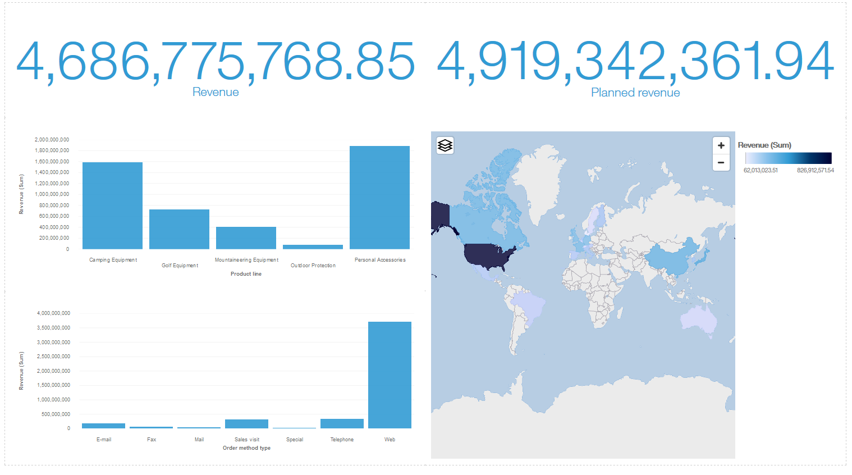

Part 1:

1. Click on the **Add to Project**.
2. Click on the **Dashboard** card.
3. Name the dashboard “Dashboard visualization for sales and marketing”.
4. Click on **Associate a** **Cognos Dashboard Embedded Service instance with your project**.
5. In the **New** tab choose the **Lite** plan and click **Create**.Click **Confirm** in the popup that appears to proceed.
6. Back in the New Dashboard page click reload to load the Cognos Dashboard Embedded Service you created and select it.
7. Click **Save**.
8. On the **Select a Template** page, under **Dashboard**, click on **Single Page**.
9. 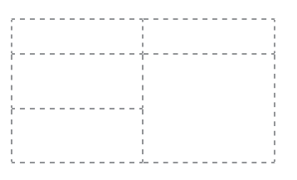Under **Single Page Layout**, clickon the template that has 2 columns, 3 rows on the left, and 2 rows on the right.
10. Click **OK**.
11. Click the **Add a Source** icon
12. select the **Sales and Marketing.csv** from the ***Data Assets*** tab.
13. Click the **Select** button (at the bottom-right of the web page).
14. The **Sales and Marketing.csv** will appear under the **Selected Sources** list.
15. Click on the **Sales and Marketing.csv** source. This opens the **Navigation Paths** for the data source. Expand the data source to show the data source columns available for reporting.
16. Drag **Revenue** from the columns list to the top-left panel of the template, then drop it when the icon in the center of the panel turns blue.
17. Drag **Planned Revenue** from the columns list to the top-right panel of the template, then drop it when the icon in the center of the panel turns blue.
18. Drag **Product Line** from the columns list to the panel below revenue, then drop it when the icon in the center of the panel turns blue. This will list the product lines.
19. Click and drag **Revenue** from the columns list on top of the **Product Line** list. Notice that a bar chart is created for you.
20. Clickand drag **Order Method Type** to the drop zone below where **Product Line/Revenue** were dropped. Then click and drag **Revenue** from the columns list onto the Order Method Type list.
21. Clickand drag **Retailer Country** to the drop zone in the middle of the bottom right drop zone. A world map visual will be displayed. Click and drag **Revenue** into the same drop zone. Your visual should look as follows:
22. 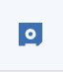**Save** the dashboard.

There are many options of what can be done with Watson Studio and dashboarding and many other capabilities. Refer to the following link for more details:

**To learn more about the data refinery:** <https://dataplatform.cloud.ibm.com/docs/content/wsj/refinery/refining_data.html>

**To learn more about Dashboards:**

<https://dataplatform.cloud.ibm.com/docs/content/wsj/analyze-data/analytics-dashboard.html>